**Tableau Sales Analysis Project Summary & Visualizations**

Overview: This project looks at sales and profit data through different lenses like categories, regions, and customer segments. Using Tableau, I created several charts to spot trends and insights, like how sales have grown year-over-year, and which categories or regions are the most profitable.

**Below are the visualizations Snapshot:**

1. **Horizontal Bar 1:** "Sales and Profit Trends by Sub-Category and Year (2021-2024)"

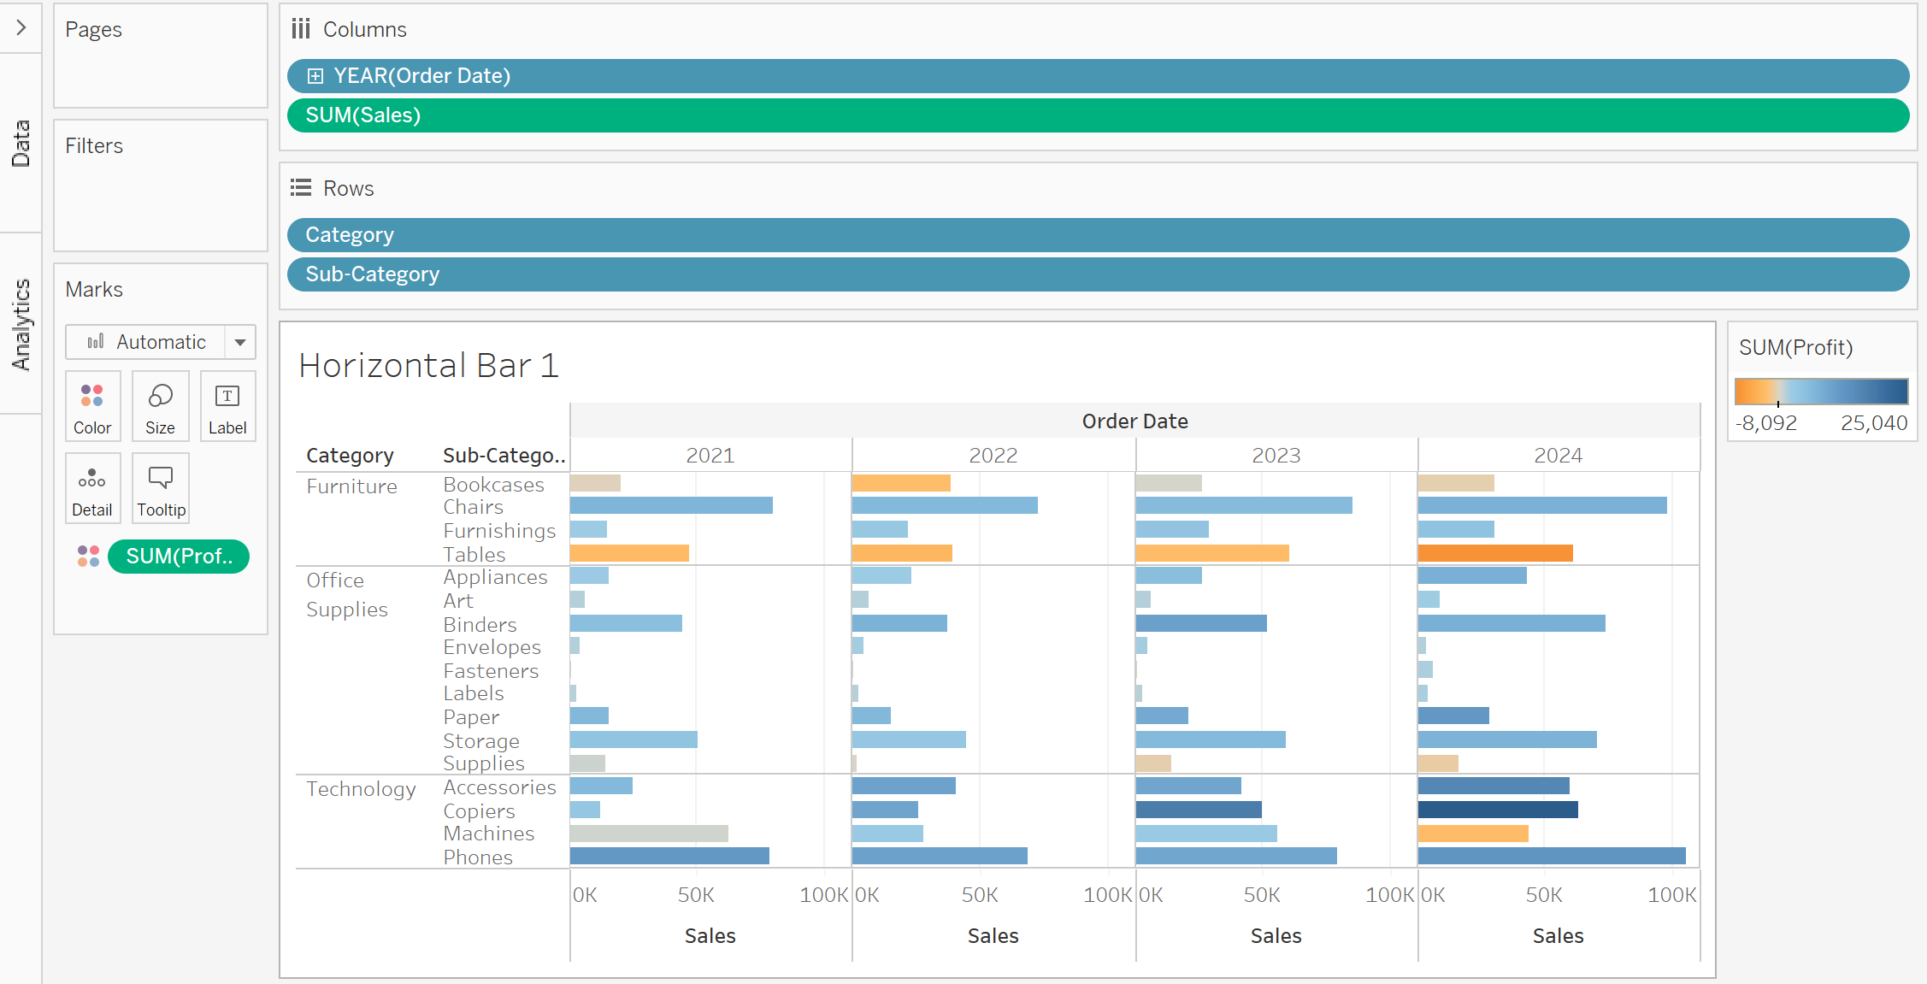

1. **Horizontal Bar 2:** "Regional Sales and Profit by Sub-Category and Year (Central, East, South, West)"

1. **Line Chart:** "Annual Sales Trend by Region and Sub-Category"

1. **Scatter Plot 1:** "Sales vs. Profit for Furniture Category, Highlighting Regional Impact by Sub-Category"

1. **Bar Chart:** "Average Unit Cost by Sub-Category”

1. **Sales Spotlight Bar Chart:** "Sales Distribution by Segment, Category, and Sub-Category"

1. **Stacked Bars:** "Sales by Year and Ship Mode (Central Region Only)"

1. **Heat Map:** "Quarterly Profit and Sales Distribution by Category"

1. **Scatter Plot 2:** "Sales vs. Profit, Segmented by Category and Segment"

1. **Pie Chart:** "Sales Distribution by Segment (% of Total Sales)"

1. **Box Plot:** "Profit Distribution by Category and Sub-Category"

1. **Tree Map:** "Sales and Profit by Region and State"

1. **Area Chart:** "Monthly Sales Trends by Year (2021-2024)"

1. **Map Visualization:** "Sales Distribution in East and South Regions (2016-2017)"

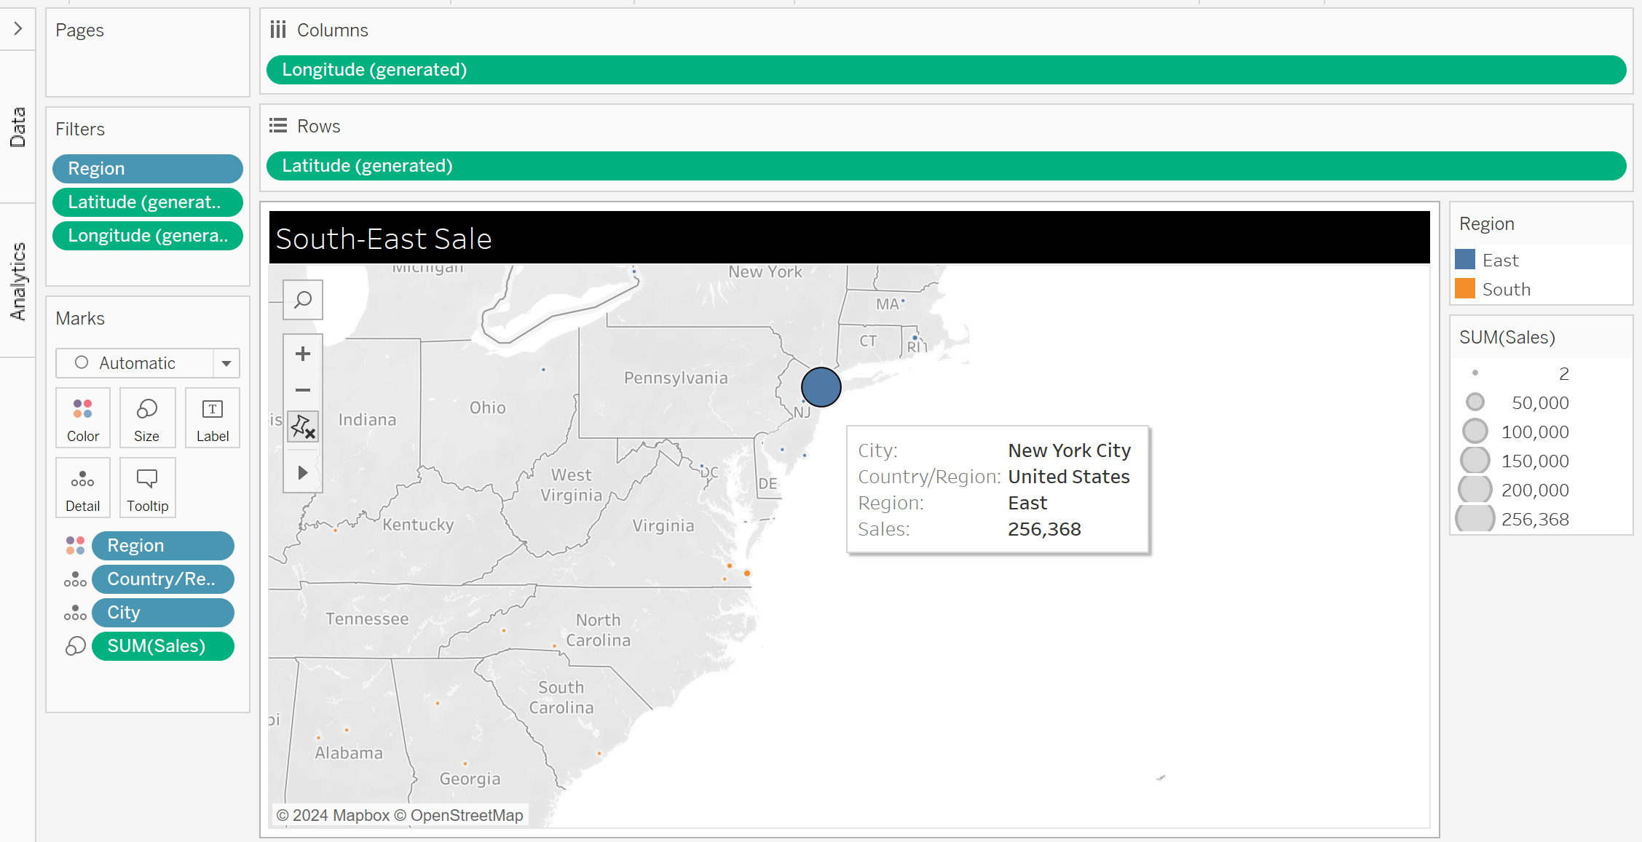

1. **Dashboard:** “South-East Sales, Avg Unit Cost, and Sales Spotlight with Global Filter for Order Year"

These visualizations together provide a comprehensive look at key sales and profit metrics, offering insights across multiple dimensions of the data.